Ideation Phase
Define the Problem Statements

Date | 29 September 2026
Team ID | 6ab3da83a238dc999eb399a3
Project Name | AI-Augmented BlogNest API
Maximum Marks | 2 Marks
Customer Problem Statement – AI Augmented Backend Development – AI BlogNest API
The AI BlogNest API is designed to address the difficulties users face in creating, managing, and organizing blog content efficiently. Users may spend considerable time writing and editing content, generating suitable titles or keywords, summarizing articles, categorizing blogs, and managing blog information manually.The customer problem statement is:“How might we help users create, manage, organize, and discover blog content more efficiently by providing an AI-powered backend API with intelligent content generation, summarization, keyword generation, categorization, and secure blog management features?”
A clear understanding of these customer needs helps the development team design an AI-augmented backend that provides useful, efficient, and scalable API services for the AI
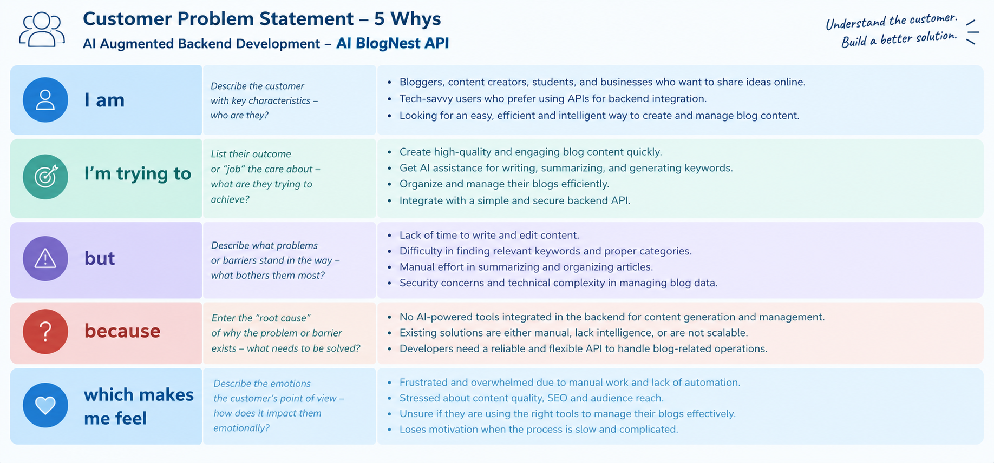
Problem Statement (PS) | I am (Customer) | I’m trying to | But | Because | Which makes me feel
PS-1 | A content creator or blogger. | Generate and manage blog content quickly. | Creating quality content and summaries manually takes considerable time. | AI assistance is not always integrated into the backend workflow. | Frustrated and less productive.
PS-2 | A developer integrating blog services into an application. | Use a secure and scalable API for blog management and AI features. | Managing authentication, blog operations, AI services, and data separately can be complex. | A unified AI-augmented backend API is needed to handle these operations efficiently. | Overwhelmed by development complexity and integration effort.

